AUTH-025
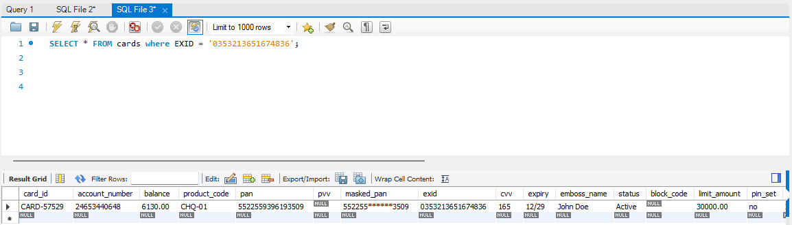
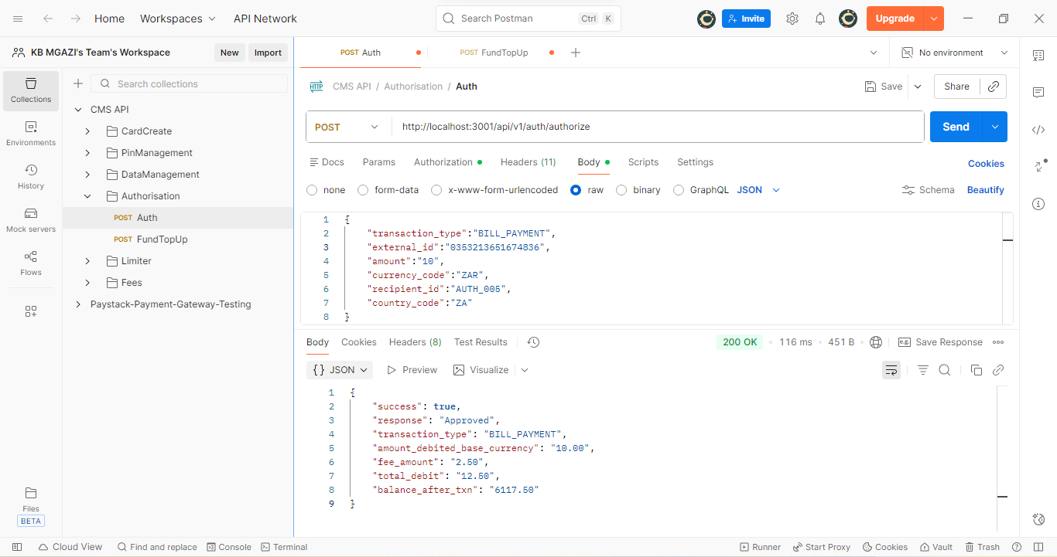
Request:
{
"transaction_type":"BILL_PAYMENT",
"external_id":"0353213651674836",
"amount":"10",
"currency_code":"ZAR",
"recipient_id":"AUTH_005",
"country_code":"ZA"
}
Response:
{
"success": true,
"response": "Approved",
"transaction_type": "BILL_PAYMENT",
"amount_debited_base_currency": "10.00",
"fee_amount": "2.50",
"total_debit": "12.50",
"balance_after_txn": "6117.50"
}

